Noisy Cell Counts

DESCRIPTION:
The data are arrays of integers corresponding to the number of cells in the sample over time. The first element data[0] is the initial count. The next element data[1] is the cell count at a later time. data[2] is the next count, and so on.
The cells are reproducing, so the elements of the array are supposed to be non-decreasing (there is no cell death), but the automatic cell counter has undercounted. In fact, the researcher has verified that the counter undercounts by 1 at random. The error rate is unknown.
Your task is to create a new non-decreasing array that is minimally different from the data array. For example, if the data = [1, 1, 2, 2, 1, 2, 2, 2, 2] then the returned array should be [1, 1, 2, 2, 2, 2, 2, 2, 2] because data[4] < data[3] is clearly an error.
The first entry of the array is correct, and does not require an adjustment.
The array will never be empty.

SOLUTION:
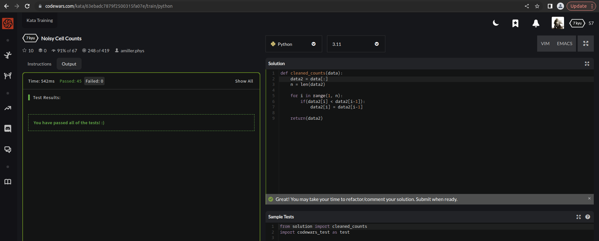

EXPLANATION:
This function takes an input array data and returns a new array that is non-decreasing and minimally different from the input array. For example, if the input array is data = [1, 1, 2, 2, 1, 2, 2, 2, 2], the returned array will be [1, 1, 2, 2, 2, 2, 2, 2, 2]. This is the smallest change that can be made to the input array to make it non-decreasing.

